# Selection statements

[Selection statements - C# reference | Microsoft Learn](https://learn.microsoft.com/en-us/dotnet/csharp/language-reference/statements/selection-statements#the-if-statement)

I’ve researched this



# Iteration statements

<https://learn.microsoft.com/en-us/dotnet/csharp/language-reference/statements/iteration-statements>

I’ve researched this



# Constants

I’ve researched this

<https://learn.microsoft.com/en-us/dotnet/csharp/programming-guide/classes-and-structs/constants>

# Arrays

I’ve researched this

<https://learn.microsoft.com/en-us/dotnet/csharp/programming-guide/arrays/>

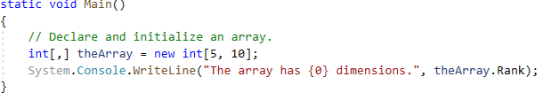



# Classes

I’ve researched this

<https://learn.microsoft.com/en-us/dotnet/csharp/fundamentals/types/classes>

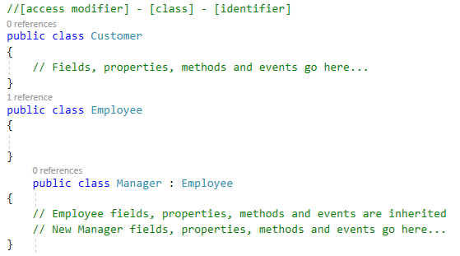

# Access modifiers

I’ve researched this

<https://learn.microsoft.com/en-us/dotnet/csharp/programming-guide/classes-and-structs/access-modifiers>

# Fields

I’ve researched this

[Fields - C# Programming Guide | Microsoft Learn](https://learn.microsoft.com/en-us/dotnet/csharp/programming-guide/classes-and-structs/fields)

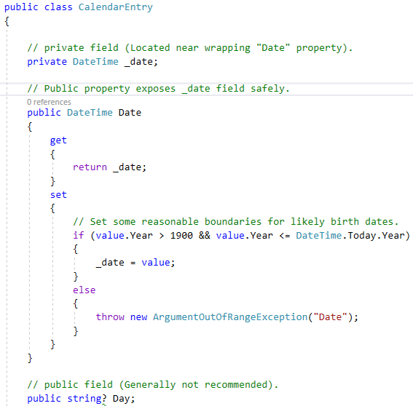

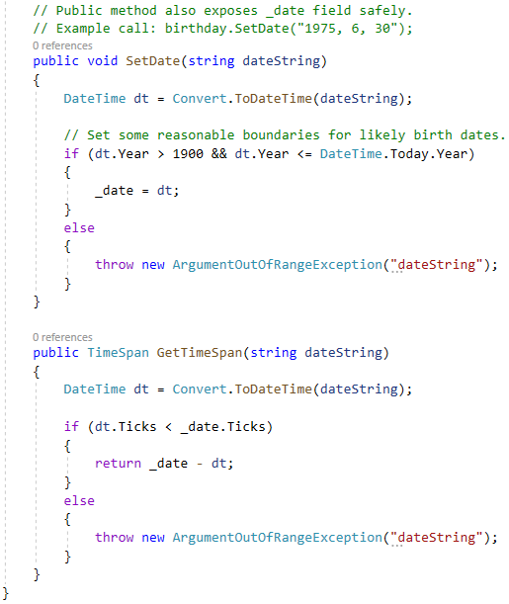

# Readonly

I’ve researched this

<https://learn.microsoft.com/en-us/dotnet/csharp/language-reference/keywords/readonly>

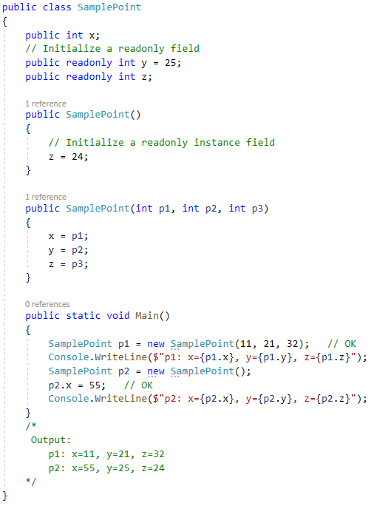



# Constructors

I’ve researched this

<https://learn.microsoft.com/en-us/dotnet/csharp/language-reference/keywords/readonly>

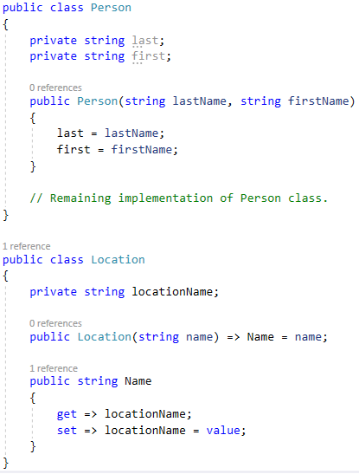

# Passing by value

I’ve researched this

<https://learn.microsoft.com/en-us/dotnet/csharp/language-reference/keywords/method-parameters>

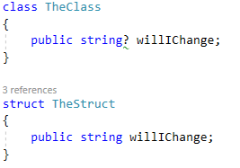



# Passing by Reference

I’ve researched this

<https://learn.microsoft.com/en-us/dotnet/csharp/language-reference/keywords/method-parameters>

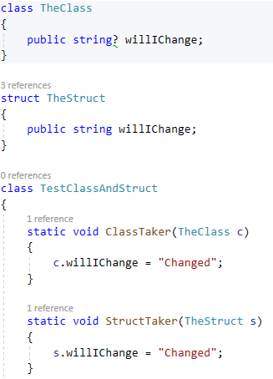

# Expression body definitions =>

I’ve researched this

<https://learn.microsoft.com/en-us/dotnet/csharp/programming-guide/classes-and-structs/methods>

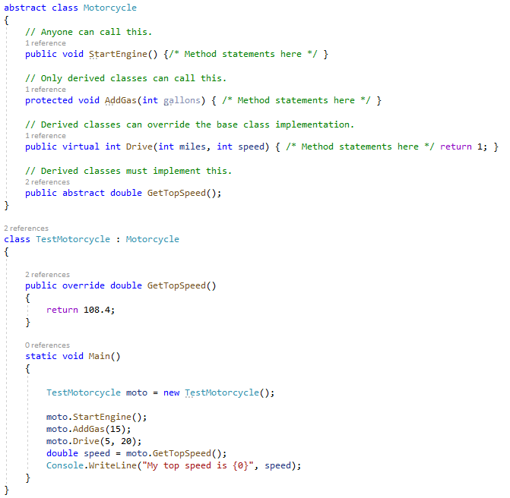



# Lambda Expressions

I’ve researched this

<https://learn.microsoft.com/en-us/dotnet/csharp/language-reference/operators/lambda-expressions>



# Generic Methods

I’ve researched this

<https://learn.microsoft.com/en-us/dotnet/csharp/programming-guide/generics/generic-methods>

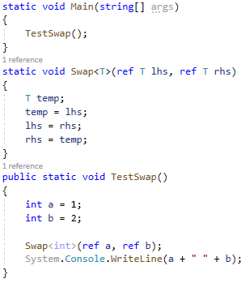



# Interfaces

I’ve researched this

<https://learn.microsoft.com/en-us/dotnet/csharp/fundamentals/types/interfaces>

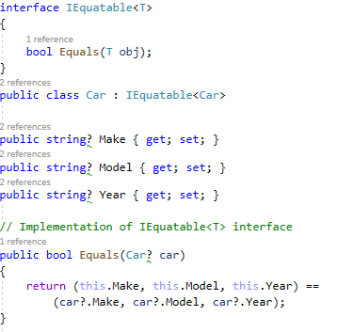

# Inheritance

I’ve tried this

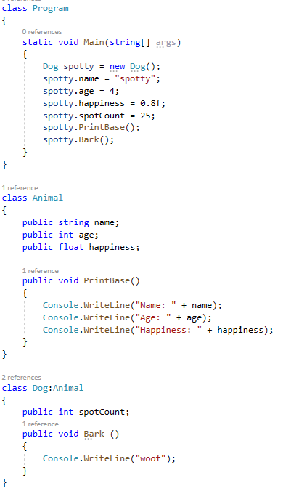

# Virtual

I’ve researched this

<https://learn.microsoft.com/en-us/dotnet/csharp/language-reference/keywords/virtual>

# Overload

I’ve researched this

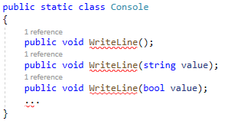

# Override

I’ve researched this

<https://learn.microsoft.com/en-us/dotnet/csharp/language-reference/keywords/override>

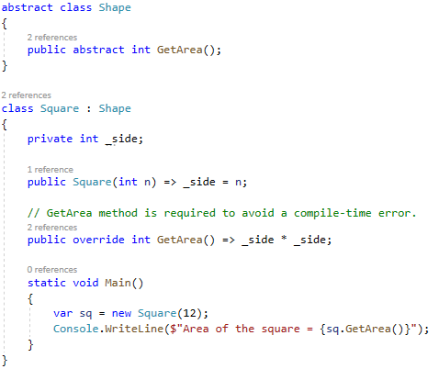 

# Abstract Classes and Abstract Class Members

I’ve researched this

<https://learn.microsoft.com/en-us/dotnet/csharp/language-reference/keywords/abstract>

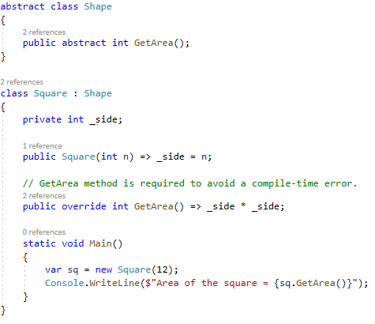



# New modifier

I’ve researched this

<https://learn.microsoft.com/en-us/dotnet/csharp/language-reference/keywords/new-modifier>

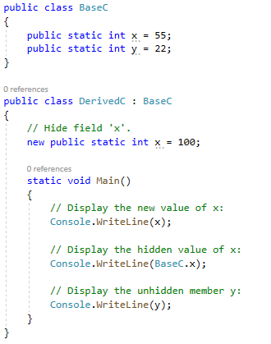



# Base

I’ve researched this

<https://learn.microsoft.com/en-us/dotnet/csharp/language-reference/keywords/base>

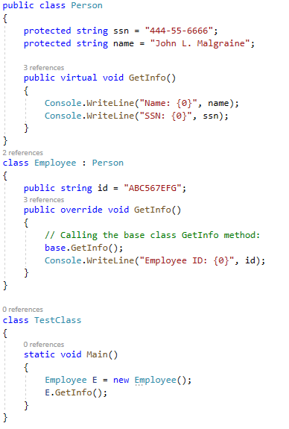

# Sealed Classes and Sealed Class Members

I’ve researched this

<https://learn.microsoft.com/en-us/dotnet/csharp/programming-guide/classes-and-structs/abstract-and-sealed-classes-and-class-members>

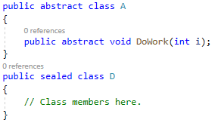

# Static

I’ve researched this

<https://learn.microsoft.com/en-us/dotnet/csharp/language-reference/keywords/static>

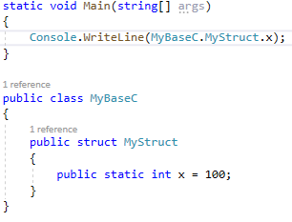



# Properties

I’ve researched this

<https://learn.microsoft.com/en-us/dotnet/csharp/programming-guide/classes-and-structs/properties>



# $ - string interpolation

I’ve researched this

<https://learn.microsoft.com/en-us/dotnet/csharp/language-reference/tokens/interpolated>

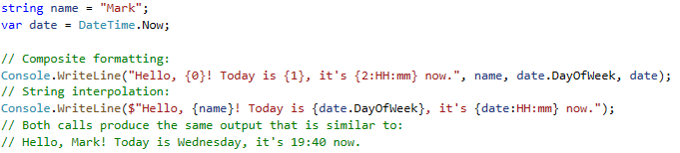



# Enumeration types

I’ve researched this

<https://learn.microsoft.com/en-us/dotnet/csharp/language-reference/builtin-types/enum>

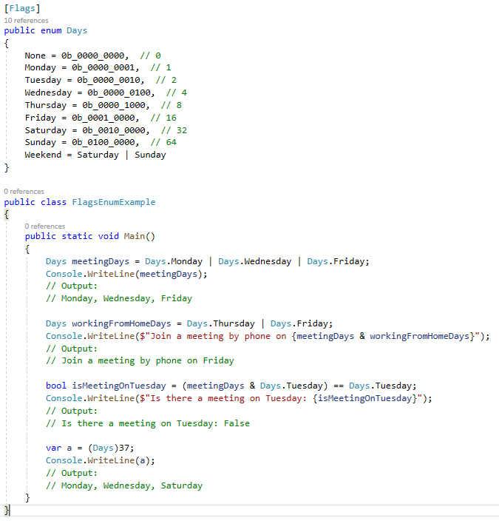 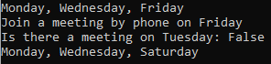

# Exceptions and Exception Handling

I’ve researched this

[Exceptions and Exception Handling | Microsoft Learn](https://learn.microsoft.com/en-us/dotnet/csharp/fundamentals/exceptions/)

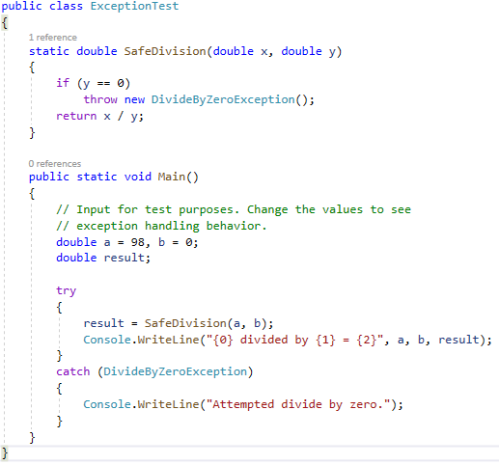



# Using statement

I’ve researched this

<https://learn.microsoft.com/en-us/dotnet/csharp/language-reference/keywords/using-statement>

# Init accessors

I’ve researched this

<https://learn.microsoft.com/en-us/dotnet/csharp/language-reference/proposals/csharp-9.0/init#init-accessors>

# Named and Optional Arguments

I’ve researched this

<https://learn.microsoft.com/en-us/dotnet/csharp/programming-guide/classes-and-structs/named-and-optional-arguments>

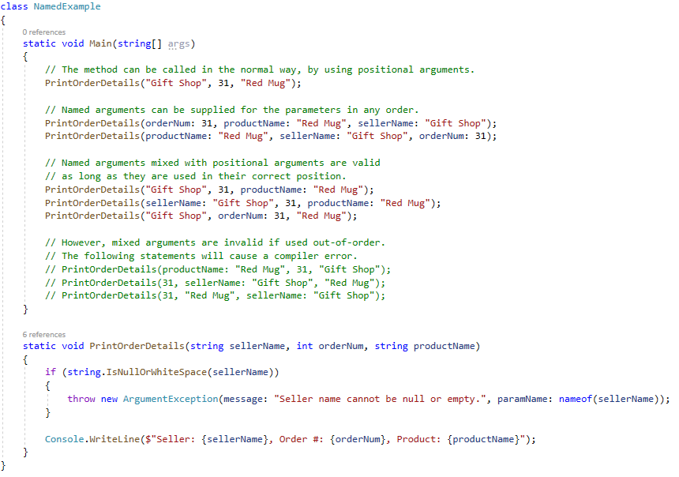

# When

I’ve researched this

<https://learn.microsoft.com/en-us/dotnet/csharp/language-reference/keywords/when>

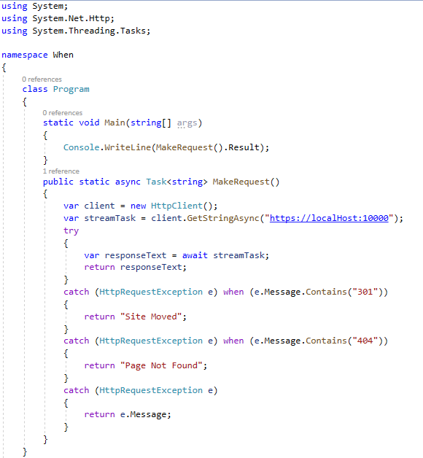



# Object and Collection Initializers

I’ve researched this

<https://learn.microsoft.com/en-us/dotnet/csharp/programming-guide/classes-and-structs/object-and-collection-initializers>

# Reflection

I’ve researched this

<https://learn.microsoft.com/en-us/dotnet/csharp/programming-guide/concepts/reflection>

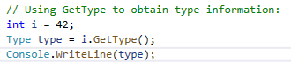



# Delegates

I’ve researched this

<https://learn.microsoft.com/en-us/dotnet/csharp/programming-guide/delegates/using-delegates>

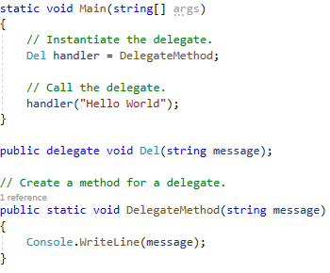



# Event

I’ve researched this

<https://learn.microsoft.com/en-us/dotnet/csharp/language-reference/keywords/event>

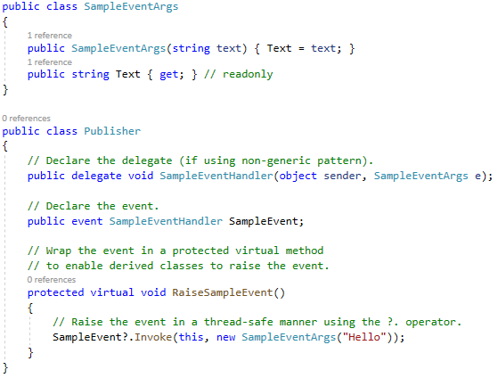

# Indexers

I’ve researched this

<https://learn.microsoft.com/en-us/dotnet/csharp/programming-guide/indexers/>

